GEOL 551: Applied Petroleum Geology   
Assignment #6 - Due 3/18/2019

Nadima Dwihusna

**Homework Task**

* Huntsman do 2D Hunt and 3d Hunt Picking
* Display the Amplitude and Time of the Huntsman

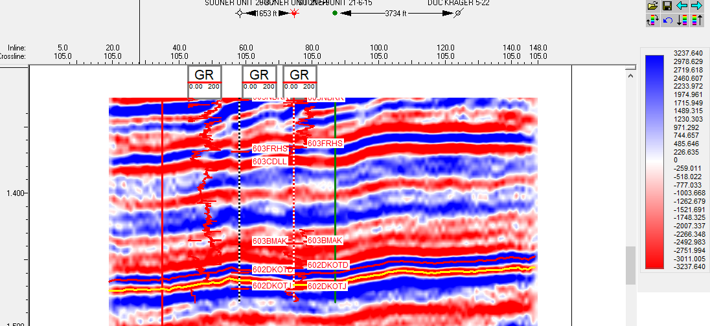

**Figure 1a**: 2D Horizon Pickings (an inline Huntsman

horizon picks under the D Sandstone)

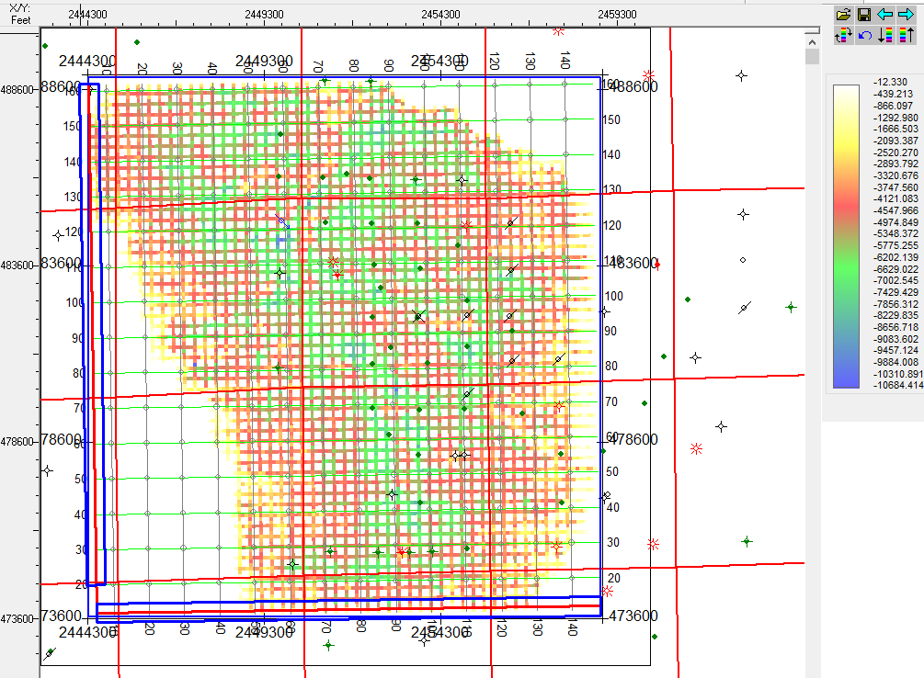

**Figure 1b**: 2D Horizon Pickings (Base Map Huntsman Pickings)

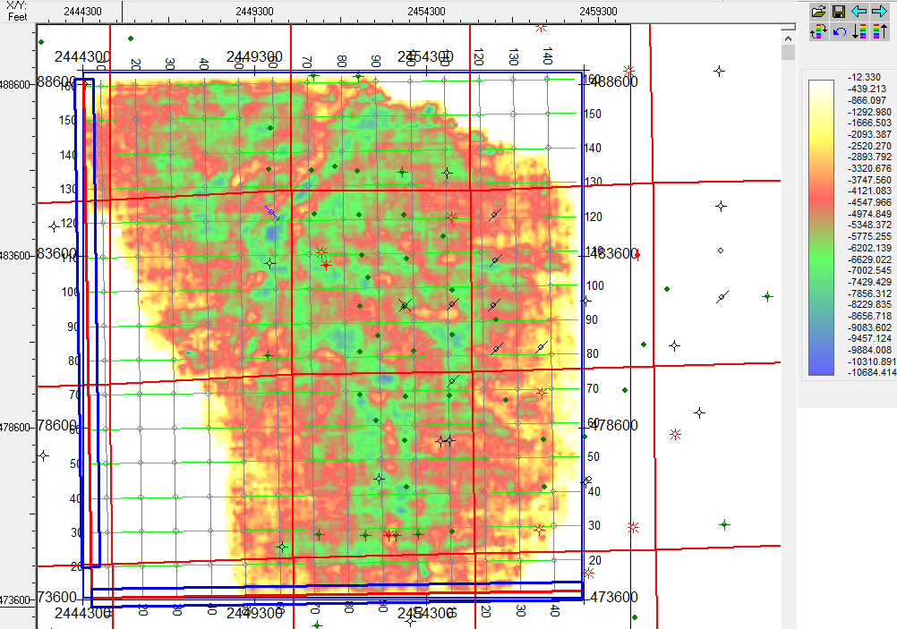

**Figure 2:** Amplitude Map of Huntsman after 3D Hunt Picks

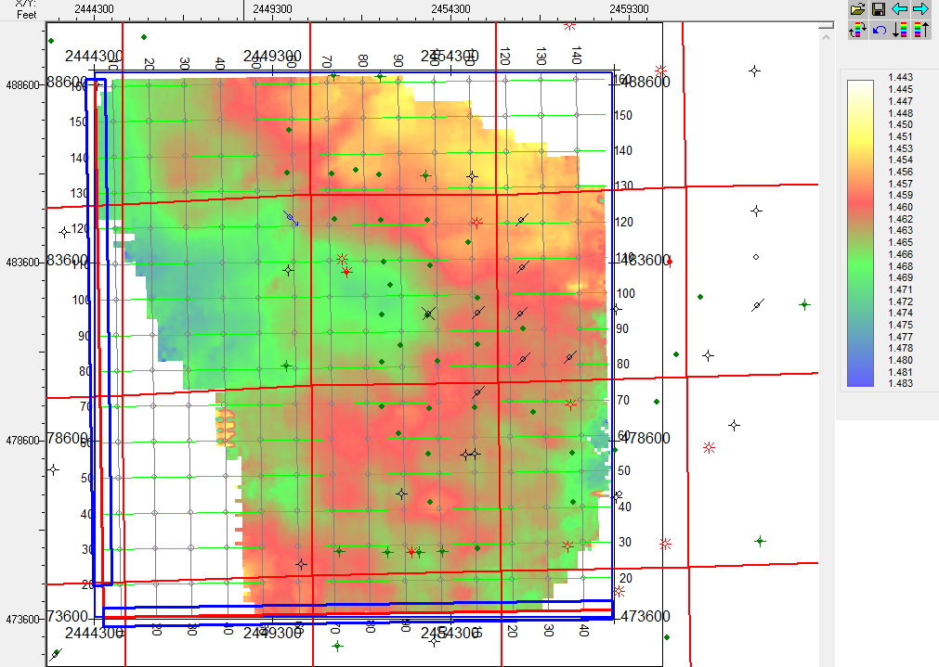

Figure 3: Time Map of Huntsman after 3D Hunt Picks